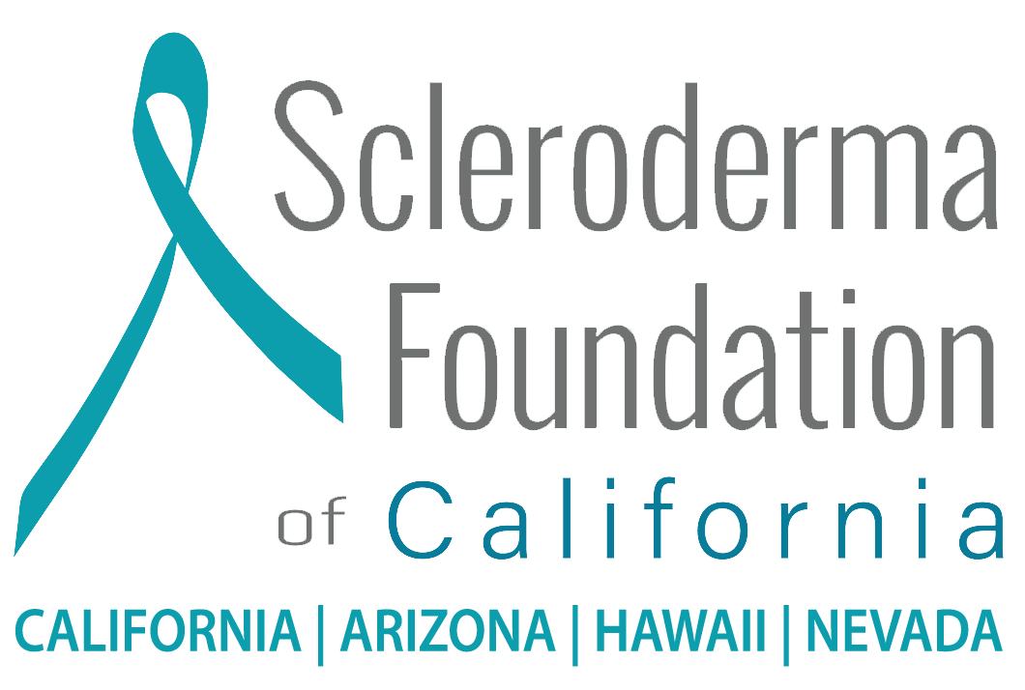

DATE:

Dear (NAME),

The Scleroderma Foundation of California LA/OC’s “A Million Steps for Scleroderma” will take place on Saturday June 27, 2026, at La Mirada Regional Park. This event was created in the spirit of raising awareness and funds, bringing our Southern California scleroderma community together for a fun filled day of activities and a non-competitive team walk around the park.

(I AM A TEAM CAPTAIN/EVENT COMMITTEE/VOLUNTEER) and (I/WE) would be grateful if (NAME OF COMPANY/PERSON) would consider contributing a (SPECIFIC REQUEST/AN ITEM) for our event raffle.

Scleroderma is a rare autoimmune connective tissue disease affecting about 300,000 Americans. It can involve most organs but frequently involves the lungs, heart, gastrointestinal system, tendons, and joints and the effects can range from very mild to life-threatening. The seriousness depends on the parts of the body which are affected. Currently, there is no cure.

The Scleroderma Foundation of California is dedicated to supporting the needs of scleroderma patients and their families. All funds raised will support the Foundation’s mission EMPOWERING the scleroderma community to LIVE better LIVES through programs dedicated to SUPPORT, EDUCATION and RESEARCH.

If you have any questions about the Foundation or need any further information, please feel free to contact the Foundation’s Executive Director, Andrew Emmett at 424-227-6475 or by email at: aemmett@myscleroderma.org

With thanks,

Volunteer
The Scleroderma Foundation of California
